item at LogiMAT 2018
12 May 2017
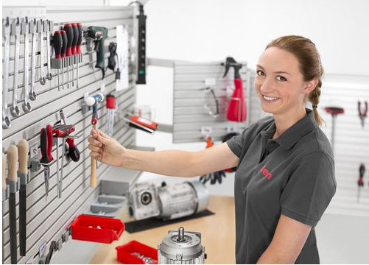

item at LogiMAT 2018
Structure and organise work benches perfectly with the Toolpanel System
More efficiency at the work bench – item Industrietechnik GmbH shows how it’s done at LogiMAT 2018. The main focus is on the new Toolpanel System, a large structure comprising a Groove Plate Profile and a range of holders that can be installed in next to no time. This addition to the item Work Bench System helps users ensure their tools are clearly organised with very little effort. The Groove Plate Profile combines 19 item system grooves in a compact space, meaning working materials and accessories can be quickly positioned precisely where needed. At Stand C71 in Hall 3, trade fair visitors also have the chance to see the new item ergolean products, which combine the principle of lean production with ergonomic aspects.
Thanks to the new Toolpanel System from item, staff can quickly customise their workstations to suit their specific needs simply by incorporating Groove Plate Profile 8 into work benches or tool trolleys. With a total of 19 system grooves, the flat design offers plenty of space for holders and accessories on the front and back. In just a matter of seconds, spanners, screwdrivers and tool bits can be placed at the optimum height and in perfect order. All users have to do is slot the appropriate holder into a groove by hand – no tools required. The new holders are also just as easy to remove. As the system groove is compatible with other components in the item MB Building Kit System, all other products in the Hook and Holder System, Shelves and other custom fixtures can be attached to it. The new Toolpanel System from item is the ideal solution for improving the structure and efficiency of work benches.
The company is also showcasing new ergolean components at LogiMAT 2018. Combining ergonomic principles and lean production requirements leads to more efficient working processes and higher productivity.
item at LogiMAT 2018: Hall 3, Stand C71
Length: 2,266 characters including spaces
Date: 1 December 2017
Image 1: More order at the work bench thanks to the new Toolpanel System from item.
Image 2: With a total of 19 system grooves, the flat design offers plenty of space for holders and accessories.

